**SOLUTION TO MIDTERM EXAM QUESTION PAPER Project Management (ALL BRANCHES) ILOC-2 SEM VIII**

What is Project?

Project is a Temporary Endeavour undertaken to accomplish a Unique Goal or unique Purpose. It comprises of Unique complex and connected activities having a one specific goal and it can be completed in specific time adhere to specific Cost (Budget) and according to Specifications.

Various Examples of Project are:

1. Building a District/ State / National Highway
2. Setting Up a scheme for Public in Health and Family welfare
3. Building a Dam or Hydro Electric Plant etc.

Project management is Application of Knowledge. Skills Tools and techniques towards various activities of the Project in order to meet project requirements.

Project Management has various activities such as Planning Organizing Staffing, directing and controlling.

Following are the important factors of Project Management:

Change In Need

Change in process

Change in Environment

Market Change

Extraordinary Competition

Focused Client, Client is Intelligent

Differentiate between Functional Pure and Matrix Organization?

Functional, Pure and Matrix Organizations

* **Functional Organization**: Functional organizations are organized around the functions the organization need to be performed.
  + Functions include: Human Resources, Information Technology, Sales, Marketing, Administration, etc.
  + This is the traditional structure of organizations
  + The “Project Management” role will be performed by a team member of a functional area under the management of a functional manager
    - Resources are controlled and authorized by functional managers
    - The “Project Management” role would act more like a “Project coordinator” or “Project Expediter” who do not usually carry the title of “Project Manager”
    - Project Management is considered a part-time responsibility
    - Authority of the “Project Manager” is very limited

Functional Organization:

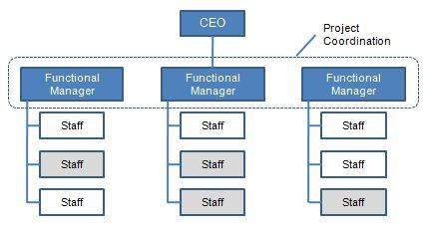

* **Pure Organization**: Pure Organizations are organized around projects for maximal project management effectiveness.
  + The Project Manager is given more authority and resources control
  + The Project Manager is responsible to the Sponsor and/or Senior Management
  + The Project Manager is usually a full-time role
  + Team members are usually co-located within the same office / virtually co-located to maximize communication effectiveness
  + There can be some functional units within organization, however, those units are having a supportive function only without authority over the project manager

Pure Organization:

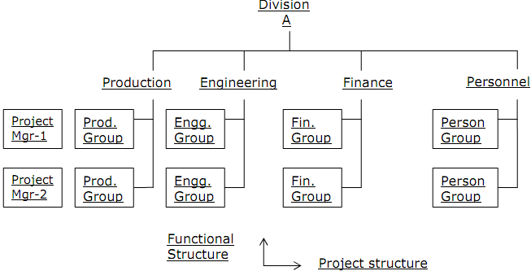

* **Matrix Organization**: Matrix Organizations are organizations with structures that carries a blend of the characteristics of functional and projectized organizations.
  + Matrix organizations can be classified as weak, balanced or strong based on the relative authority of the Functional Manager and Project Manager
  + If the “Project Manager” is given a role of more like “Project Co-ordinator” or “Project Expediter”, then the organization is considered “Weak Matrix”
  + If the “Project Manager” is given much more authority on resources and budget spending, the organization is considered “Strong Matrix”
  + The differentiations between Funcational Organization vs Weak Matrix and also Projectized Organization vs Strong Matrix are not very clear cut

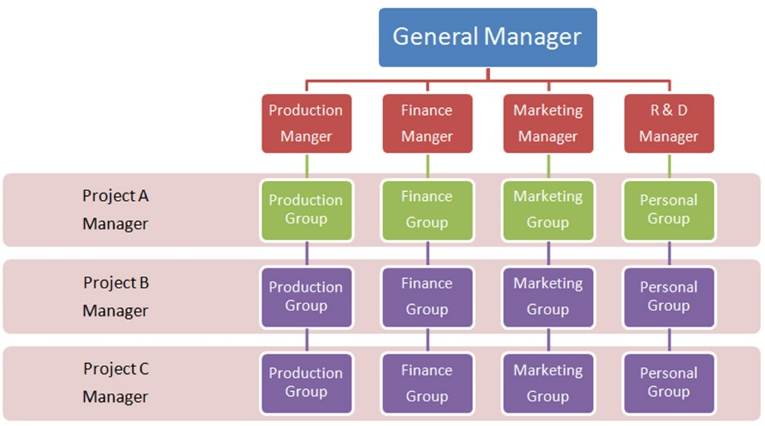

What are Various Phases of Project Management?

* [The project initiation stage](https://venngage.com/blog/project-life-cycle/#1): Define project goals, evaluate feasibility and establish the project’s purpose and stakeholders.
* [The project planning stage](https://venngage.com/blog/project-life-cycle/#2): Create a comprehensive project blueprint outlining tasks, timelines and resource allocation.
* [The project execution stage](https://venngage.com/blog/project-life-cycle/#3): Put the project plan into action, ensuring effective communication and coordination among team members.
* [The project monitoring & controlling stage](https://venngage.com/blog/project-life-cycle/#4): Track project progress, identify any deviations and make necessary adjustments to keep the project on course.
* [The project closure stage](https://venngage.com/blog/project-life-cycle/#4): Complete all project tasks, obtain client approval and conduct a thorough review to capture valuable insights for future projects.

**OR Define-🡪 Plan🡪Execute🡪 Closure🡪 Evaluation are the phases of PM** 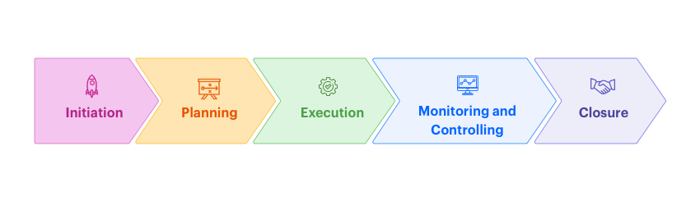

Weighted Scoring Model with Suitable Example:

The weighted scoring model is a prioritization technique that involves team members assigning a numerical value to product initiatives based on predefined criteria.

Product teams use the model to evaluate ideas, prioritize features, select tools, assess risks, or allocate resources, to name just a few.

A weighted scoring model is a technique that enables product and project managers to make informed and objective prioritization decisions.

It’s based on the multiple-criteria decision-making mathematical model, and it involves assigning numerical values to features and initiatives based on predefined criteria, like value and effort.

**When to use the weighted scoring method in product and project management?**

Product and project managers use the weighted scoring model to make important decisions.

This could be:

Idea evaluation

Feature prioritization

Selecting a tool

Risk assessment

Resource allocation

Prioritization of outstanding tasks or backlog items

Overall, the weighted scoring model is preferred for complex and high-stakes decisions.

| **ROI** | **Cost** | **Effort** | **Sustain- ability** | **Risk** | **Time** | **Quality** | **Total Score** |
| --- | --- | --- | --- | --- | --- | --- | --- |
| **Weight** | .20 | .20 | .15 | .15 | .10 | .10 | .10 | 1.00 |
| **Option 1** | 3 * .20 = 0.6 | 2 * .20 = 0.4 | 5 * .15 = 0.75 | 2 * .15 = 0.3 | 5 * .10 = 0.5 | 1 * .10 = 0.1 | 3 * .10 = 0.3 | 0.42 * 100 = 42 |
| **Option 2** | 2 * .30 = 0.4 | 2 * .20 = 0.4 | 4 * .15 = 0.6 | 2 * .15 = 0.3 | 5 * .10 = 0.5 | 2 * .10 = 0.2 | 1 * .10 = 0.1 | 0.35 * 100 = 35 |
| **Option 3** | 3 * .20 = 0.6 | 4 * .20 = 0.8 | 1 * .15 = 0.15 | 4 * .15 = 0.6 | 5 * .10 = 0.5 | 1 * .10 = 0.1 | 3 * .10 = 0.3 | 0.44 * 100 = 44 |
| **Option 4** | 1 * .20 = 0.2 | 1 * .20 = 0.2 | 5 * .15 = 0.75 | 2 * .15 = 0.3 | 3 * .10 = 0.3 | 4 * .10 = 0.4 | 5 * .10 = 0.5 | 0.37 *100 = 37 |
| **Option 5** | 3 * .20 = 0.6 | 2 * .20 = 0.4 | 5 * .15 = 0.75 | 5 * .15 = 0.75 | 3 * .10 = 0.3 | 2 * .10 = 0.2 | 3 * .10 = 0.3 | 0.47 * 100 = 47 |

Project Management Knowledge Areas:

**1. Project integration management**

**2. Project scope management**

**3. Project time management**

**4. Project cost management**

**5. Project quality management**

**6. Project resource management**

**7. Project communications management**

**8. Project risk management**

**9. Project procurement management**

**10. Project stakeholder management**

What is Net Present Value?

The basic financial concept of time value money states that the money you have known is more valuable than the money you collect later on. This is because you can use it now to earn more money by running a business or buying something now and selling it later for more, or simply putting it in the bank and earning more interest. The money received in the future is also less valuable because inflation erodes its purchasing power. But how do you compare the value of money now with the value of money in the future? This is where net present value plays an important role. Let us discuss what net present value is.

Net Present Value or NPV is the sum of the present value of cash inflows and outflows. In other words, it is the difference between the present values of cash inflows and the present value of cash outflows over some time.

Net Present Value Formula

NPV is a strong approach to determine if the project is profitable or not. It considers the interest rate, which is generally equivalent to the inflation rate, Hence, the real value of money now at each year of operation is considered.

Following are the formulas used to calculate NPV.

In case of even cash flows, the following NPV formula can be used:

NPV= - (Initial Investment) + ∑ { (Net Cash Flow)/ (1+r)^t}

r is the Discount Rate and t is the tenure or Year for which Net Cash Flow is provided

NPV can also be calculated as:

NPV = Present Value of expected cash flows - Present value of cash invested.

NPV Decision Rule

The following NPV signs explain whether the investment is good or bad.

NPV > 0 - The present value of cash inflows is more than the present value of cash outflows. The money earned on the investment is more than the money invested. Hence, it is a good investment.

NPV = 0 - The present value of cash flows is more than the present value of cash outflows. The money earned on the investment is equal to the money invested. Therefore, there is no difference between cash inflows and cash outflows.

NPV < 0 - The present value of cash inflows is less than the present value of cash outflows. The money earned on the investment is less than the money invested. Hence, it is not a fruitful investment.

Solution to problem:

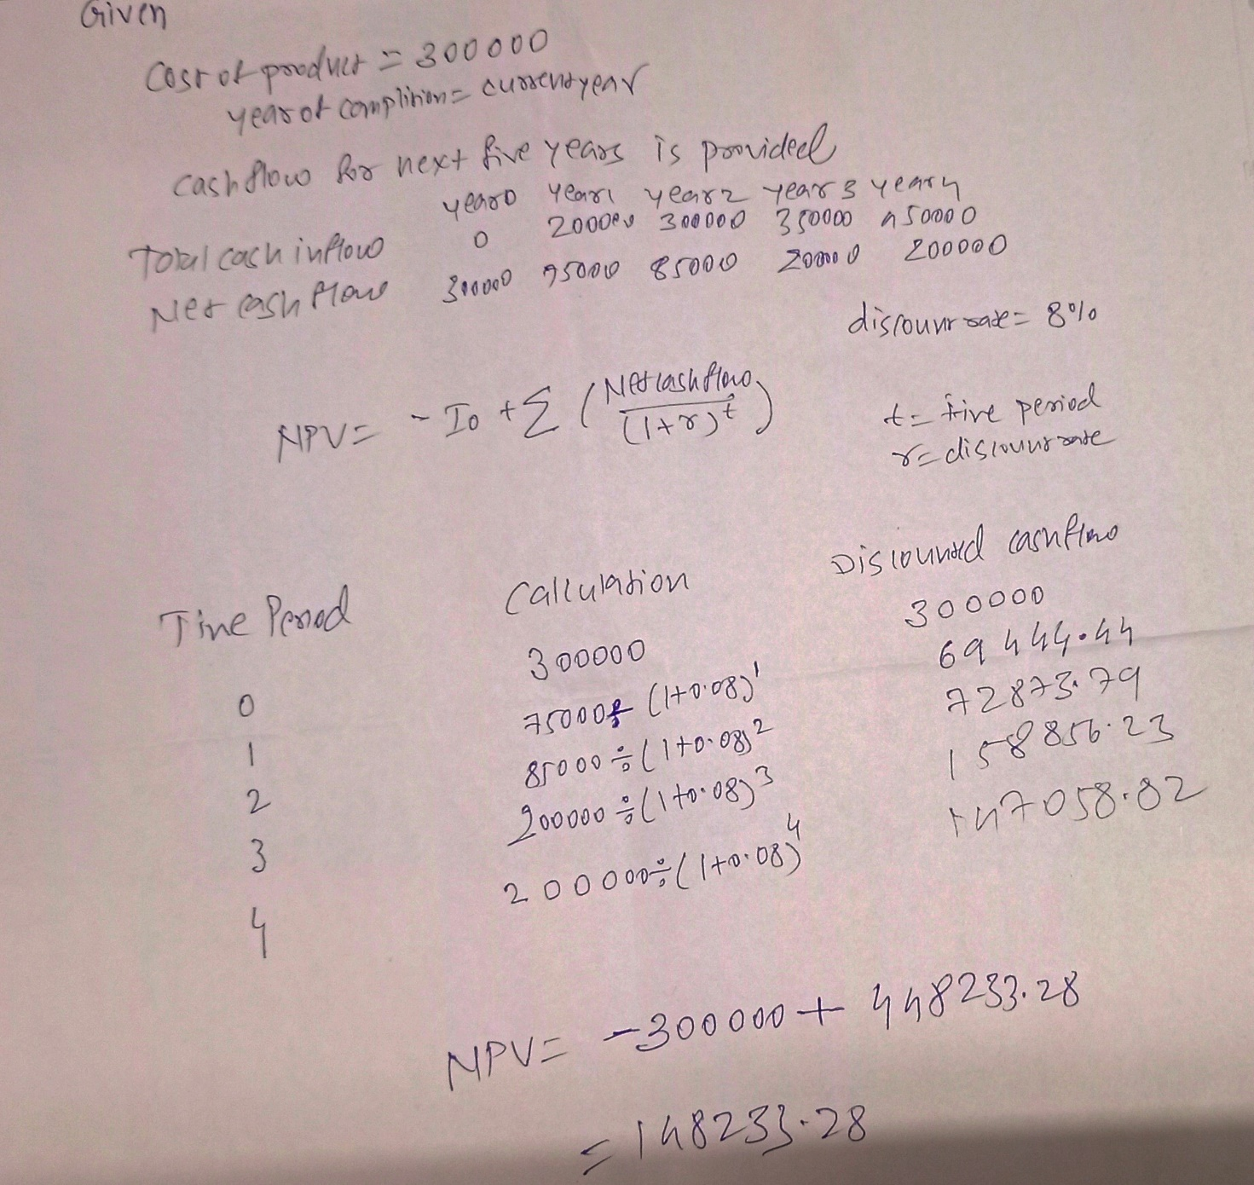

What are the Contents of Project Charter? Who prepares it?

A project charter includes an overview, the scope, an approximate schedule, an outline of necessary resources, and an estimated budget. A project manager generally writes the charter. Project sponsors approve it.

Topics covered in the project charter

Project objectives and constraints. First, outline what your main objectives are for the project and identify potential constraints or obstacles that could prevent you from achieving them.

Project charter templates often include the following parts of the project:

* **Project goal.**This documents the reasons for undertaking the project in clear, concise language. This should determine the project's scope.
* **Project participants.** This identifies who will be involved in the project and clearly states their roles.
* **Stakeholders.**This identifies project sponsors or other people who will be directly affected by the project and need to know about its progress.
* **Requirements.**This identifies the resources required for the project's objectives to be achieved.
* **Constraints.** This documents potential roadblocks or bottlenecks and should help prepare participants for the potential issues of the project.
* **Implementation milestones.** This identifies the start and ideal completion dates, as well as dates for other potentially important checkpoints, like a project schedule.
* **Communication.**This specifies how the project manager will communicate with project owners, participants and key stakeholders throughout the project.
* **Deliverables.**This documents what specific products, processes or services the project provides upon completion.
* **Cost.**This identifies a general overview of the project budget.

The project manager should create the project charter at the beginning of the project. Signing the document can also act as a way to authorize the project -- giving the project manager the go-ahead to officially begin executing the project. This includes the authority to begin employing organizational funds and resources. For larger projects that are multiphase, project managers can create a charter for each phase.

Typical Project Charter is specified blow:

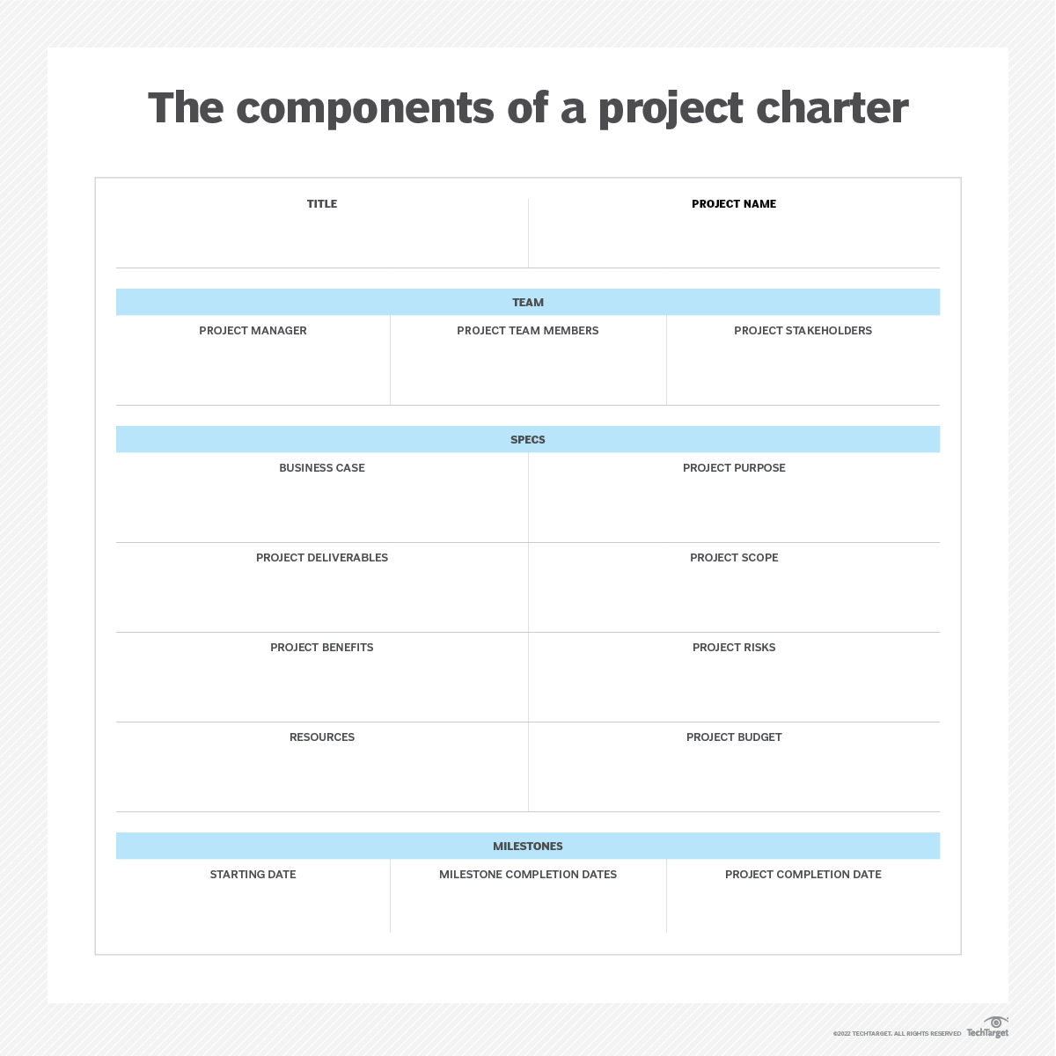

Project Selection Models:

Non Numerical Methods:

Non-Numeric Project Selection Models

Non – Numeric project selection models have further 6 types, which we need to discuss in detail.

* The Sacred Cow
* The Operating Necessity
* The Competitive Necessity
* The Product Line Extension
* Comparative Benefit Model
* Q-Sort Model

**1. The Sacred Cow**

The senior and he powerful official in the company suggest the project in this case. Mostly the project is simply initiated from an apparent opportunity or chance which follows an un-established idea for a new product, for the designing & adoption of the latest information system with universal database, for the establishment of a new market or for some other category of project that demands the investment of the resources of the organization.

The project is created as an immediate result of this bland approach for investigating whatever the boss has proposed. The sacredness of the project reflects the fact that it will be continued until ended or until the boss himself announces the failure of the idea & ends it.

**2. The Operating Necessity**

If a plant is threatened by the flood, then it is not much complex and effortful to start a project for developing a protective desk. This is the best example of operating a necessity. Potential projects are evaluated by using this criterion of project selection by the XYZ steel corporation.

Certain questions come in front of the project is needed in order to keep the system functioning like is the estimated cost of the project is effective for the system? If the answer to such an important question is yes, then the project costs should be analyzed to ensure that these are maintained as the minimum and compatible with the success of the project. However, the project should be financed.

**3. The Competitive Necessity:**

Precedence is taken by the operating necessity projects over competitive necessity projects regarding investment. But both of these types of project selection models are considered much useful & effective as compared to other select models.

**4. The Product Line Extension:**

In case of the product line extension, a project considered for development & distribution of new products will be evaluated on the basis of the extent to which it suits the company’s current product lines, fortify a weak line, fills a gap, or enhanced the line in a new & desirable direction.

In certain cases, careful evaluations of profitability is not needed. The decision-makers can perform actions on the basis of their belief about the probable influence of the addition of the new product to the line over the entire performance of the system.

**5. Comparative Benefit Model:**

According to this selection model, there are several projects that are being considered by the organization. That subset of the projects that are selected by the senior management of the organization can provide the most benefits to the company. But comparing various projects is not an easy task.

**For example,** some projects are related to the new products, some are related to the computerization of particular records, others are related to make alterations in the method of production and some of them may contain such areas that cannot be easily categorized.

There is no formal method of selection of projects in the organization but it is the perception of the selection committee members that certain projects will benefit the company more than the others even they lack the suitable way to specify or measure the proposed benefit.

For all sorts of projects, if not a formal model, the concept of comparative benefits is enormously used for selection decisions. **United States Companies** considering various social programs for providing funds to them to use this concept to make the decisions.

All the considered projects with positive recommendations are examined by the senior management of the funding organization in order to make an effort to develop a portfolio that can effectively suit the objectives & budgets of the organization.

**6. Q-Sort Model**

The Q-Sort model is one of the most straightforward techniques for ordering projects. According to their relative merits, the projects are first divided into three groups which are Good, Fair and Poor. The main group is further subdivided into the two types of fair-minus and fair-plus if any group has more than eight members.

The projects within each type are ranked from best to worst when all types have eight or fewer members. Again relative merit provides the basis for determining the order. The specific criterion is used by the rater to rank each project or he may merely use general entire judgment.

One person has the responsibility to carry out the process for evaluation & selection of the project. In certain cases, there is a selection committee for performing such a process. If the task is handled by the committee, individual ranking can be built anonymously and the committee examines the set of anonymous rankings for consensus.

These ranking differ from to some degree from rater to rater but that difference is not much enhanced because the selected individuals for such committees seldom differ increasingly on their consideration for the suitability for the parent organization.

Finally, the projects are selected on the sequence of preferences, though they are generally assessed on a financial basis before final selection. There are certain other non-numeric models for rejecting or accepting projects.

### **Numeric Project Selection Models (Profit/Profitability)**

The profitability is used as the only measure of acceptability by the majority of organizations using different types of project selection models. The following are some of the numeric models for project selection.

* Payback Period
* Average Rate of Return
* Discounted Cash Flow
* Internal Rate of Return (IRR)
* Profitability Index
* Other Profitability Models

**Payback Period**

The initial fixed investment in the project divided by the forecasted annual net cash inflows from the project is referred to as the payback period for the project. The number of years needed by the project to refund its initial fixed investment is reflected in the ratio of these quantities.

For example, suppose a project costs **$200,000** to operate and has annual net cash inflows of **$40,000**. Then

**Payback Period = $200,000 / $40,000v = 5 Years**

This method supposes that the cash inflows will die-hard to the minimum extent to pay back the investment, and any cash inflows outside the payback period are ignored. This method also functions as an inadequate representative for the risk. The company faces less risk when it recovers the initial investment fast.

**Average Rate of Return:**

The ratio of the average annual profit (either after or before taxes) to the average or initial investment in the project is referred to as the average rate of return. It is mostly misunderstood as the reciprocal of the payback period.

The average rate of return does not generally equal the reciprocal of the payback period because average annual profits are generally not equivalent to the net cash inflows. In the above-mentioned example, suppose the average annual profits are **$30,000**

**Average Rate of Return = $30,000 / $200,000 = 0.15**

None of the two above mentioned evaluation methods are effective for project selection, though the payback period is frequently used and exhibits reasonable value for decisions related to cash budgeting. These two models have a major advantage in the shape of simplicity, but none of them cover the important concept of the time value of money.

**Discounted Cash Flow**

The discounted cash flow method is also called the Net Present Value (NPV) method. The net present value of all cash flows is determined by discounting them by the required rate of return in this method.

Project Selection Models

**Where k** = the required rate of return,

**Ft =** the net cash flow in period t and

**Ao =** the initial cash investment

In order to cover the effect of inflation in the equation

Project Selection Models

Where **pt** is the forecasted rate of inflation during the period t.

Net cash flow is likely to be negative in the early life of the project because of the potential outflow in the form of the initial investment. However, cash flow will become positive when the project acquires success. If the sum of the net present value of all forecasted cash flows throughout the life of the project is positive, the project is acceptable.

A simple example will be adequate. Suppose a project has an initial investment of $100,000. It has a net cash inflow of **$25,000 per year** for a period of eight years. The required rate of return for the project is 15% with an inflation rate of **3% p.a**. Now the NPV of this project is calculated as below

Project Selection Models

The **Net Present Value** of the project is positive because the present value of the inflows is higher than the present value of the outflows. So this should be acceptable.

**Internal Rate of Return (IRR)**

If there are two sets expected cash flows, one for expected cash inflows and other for expected cash outflows then the **Internal Rate of Return** is the discount rate that equalizes the present value of the two sets of flows. If **Rt** is the forecasted cash inflow for period t and At is a forecasted cash outflow in the period t, the internal rate of return is the value of k that satisfies the following equation

Project Selection Models

The value of **k** is ascertained by trial & error.

**Profitability Index**

The net present value of all future expected cash flows divided by the initial investment is referred to as the profitability index. The profitability index is also called the benefit-cost ratio. The [**project**](https://www.businessstudynotes.com/finance/project-definition-characteristics-project/)may be accepted if this ratio is higher than 1.0.

**Other Profitability Models**

The models just explained have different variations that fall into the following three groups:

1. Those that further split the net cash flow into components that make up the net flow
2. Those that contain particular terms to acquaint risk (uncertainty) into the assessment
3. Those that widen the analysis to view impacts that the project can have on activities or projects in the company

What Is a Work Breakdown Structure (WBS)?

**A work breakdown structure (WBS) is a visual, hierarchical and deliverable-oriented deconstruction of a project.** It is a helpful diagram for project managers because it allows them to break down their project scope and visualize all the tasks required to complete their projects.

All the steps of project work are outlined in the work breakdown structure chart, which makes it an essential project planning tool. The final project deliverable, as well as the tasks and work packages associated with it rest on top of the WBS diagram, and the WBS levels below subdivide the project scope to indicate the tasks, deliverables and work packages that are needed to complete the project from start to finish.

Project managers make use of project management software to lay out and execute a work breakdown structure. When used in combination with a Gantt chart that incorporates WBS levels and task hierarchies, project management software can be especially effective for planning, scheduling and executing projects.

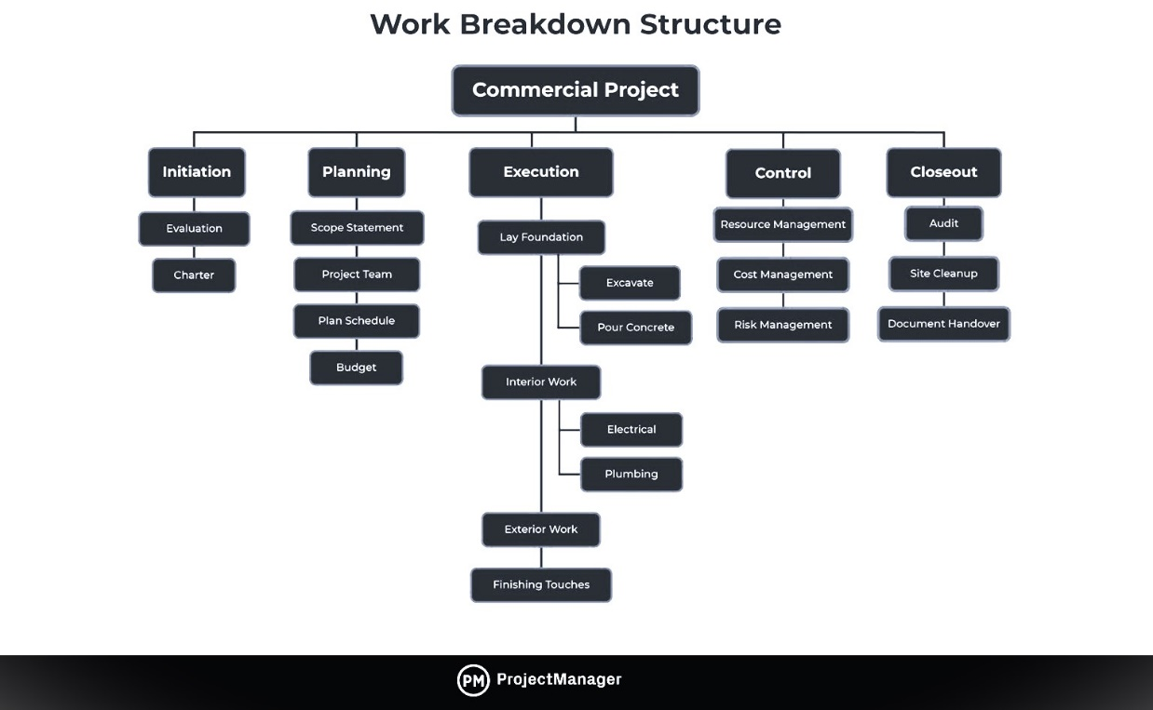

WBS for Student Training Work Shop: A hierarchical Structure or Gantt Chart method can be represented

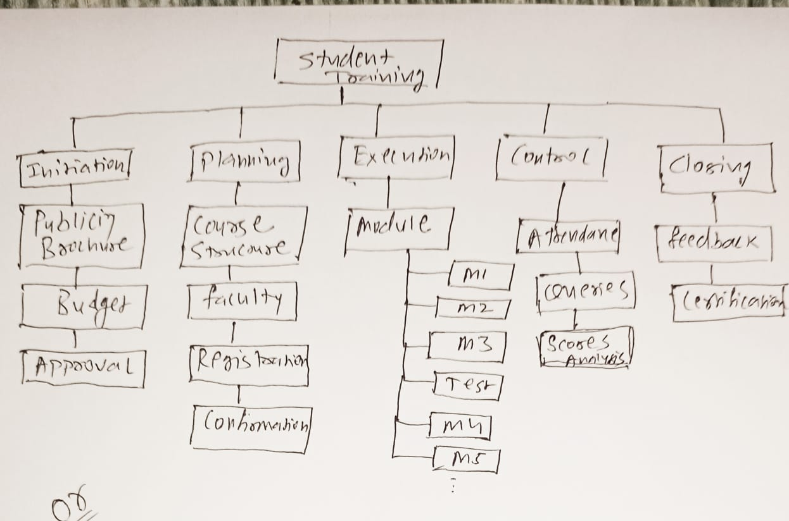

**OR**

|  |  |  |  |  |  |  |  |  |  |  |
| --- | --- | --- | --- | --- | --- | --- | --- | --- | --- | --- |
|  |  |  |  |  |  |  |  |  |  |  |
| sr | Tasks | Week 1 | Week 2 | Week 3 | Week 4 | Week 5 | Week 6 | week7 | Week8 |  |
| 1 | Publicity |  |  |  |  |  |  |  |  |  |
| 2 | Registration |  |  |  |  |  |  |  |  |  |
| 3 | Moduile1 |  |  |  |  |  |  |  |  |  |
| 4 | Module2 |  |  |  |  |  |  |  |  |  |
| 5 | Module 3 |  |  |  |  |  |  |  |  |  |
| 6 | Review Test1 |  |  |  |  |  |  |  |  |  |
| 7 | Re Test for Improvement |  |  |  |  |  |  |  |  |  |
| 8 | Module4 |  |  |  |  |  |  |  |  |  |
| 9 | Module5 |  |  |  |  |  |  |  |  |  |
| 10 | Review Test 2 |  |  |  |  |  |  |  |  |  |
| 11 | Re Terst for Improvement |  |  |  |  |  |  |  |  |  |
| 12 | Doubt Solving |  |  |  |  |  |  |  |  |  |
| 13 | Final Certificate Exam |  |  |  |  |  |  |  |  |  |
| 14 | Improvement |  |  |  |  |  |  |  |  |  |
| 15 | Feed Back |  |  |  |  |  |  |  |  |  |
| 16 | Certification |  |  |  |  |  |  |  |  |  |
|  |  |  |  |  |  |  |  |  |  |  |
|  |  | Gantt Chart for Student Training program | | | | |  |  |  |  |
|  |  |  |  |  |  |  |  |  |  |  |

x---------------------x-----------------------x